***SQL QUERIES***

1- **Total revenue** : ***The sum of the total price of all pizza orders.***

select sum(total_price) as total_revenue from thehot_pizza_sales

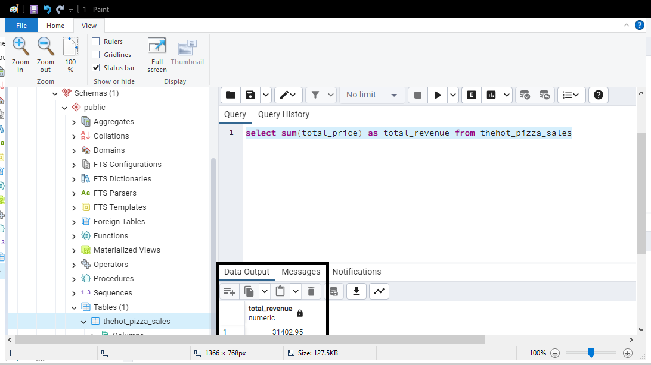

**2- Average Order Value : *The average amount spent per order, calculated by dividing the total revenue by the total number of orders.***

select sum(total_price) / count(distinct order_id) as avg_order_value from thehot_pizza_sales

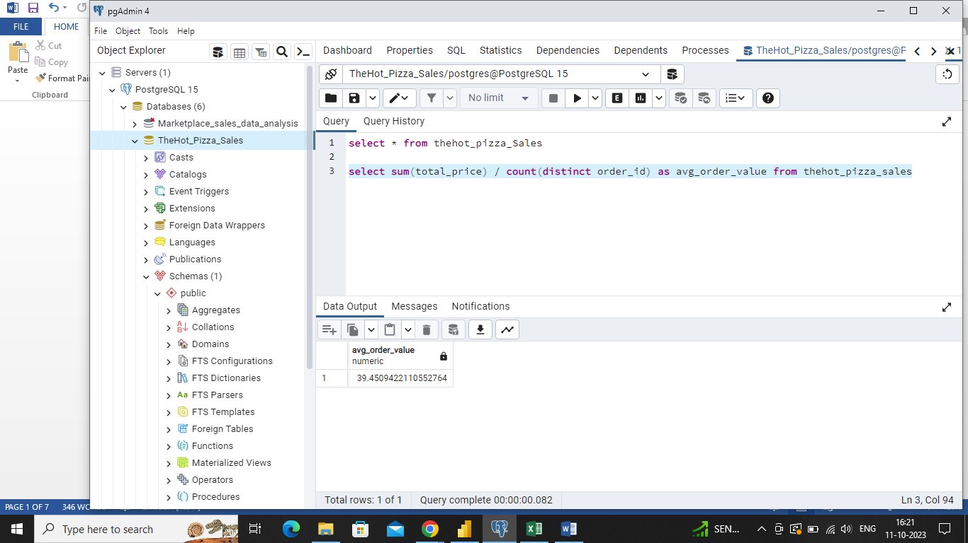

**3- Total pizzas sold :** ***The sum of the quantities of all pizzas sold.***

select sum(quantity) as total_pizza_sale from thehot_pizza_sales

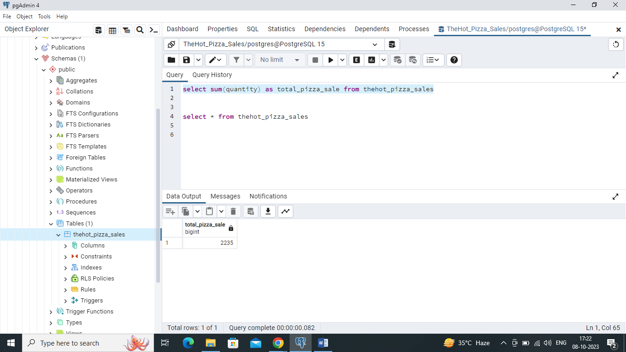

**4- Total Orders :** ***The total numbers of orders placed.***

select count(distinct(order_id)) as total_orders from thehot_pizza_sales

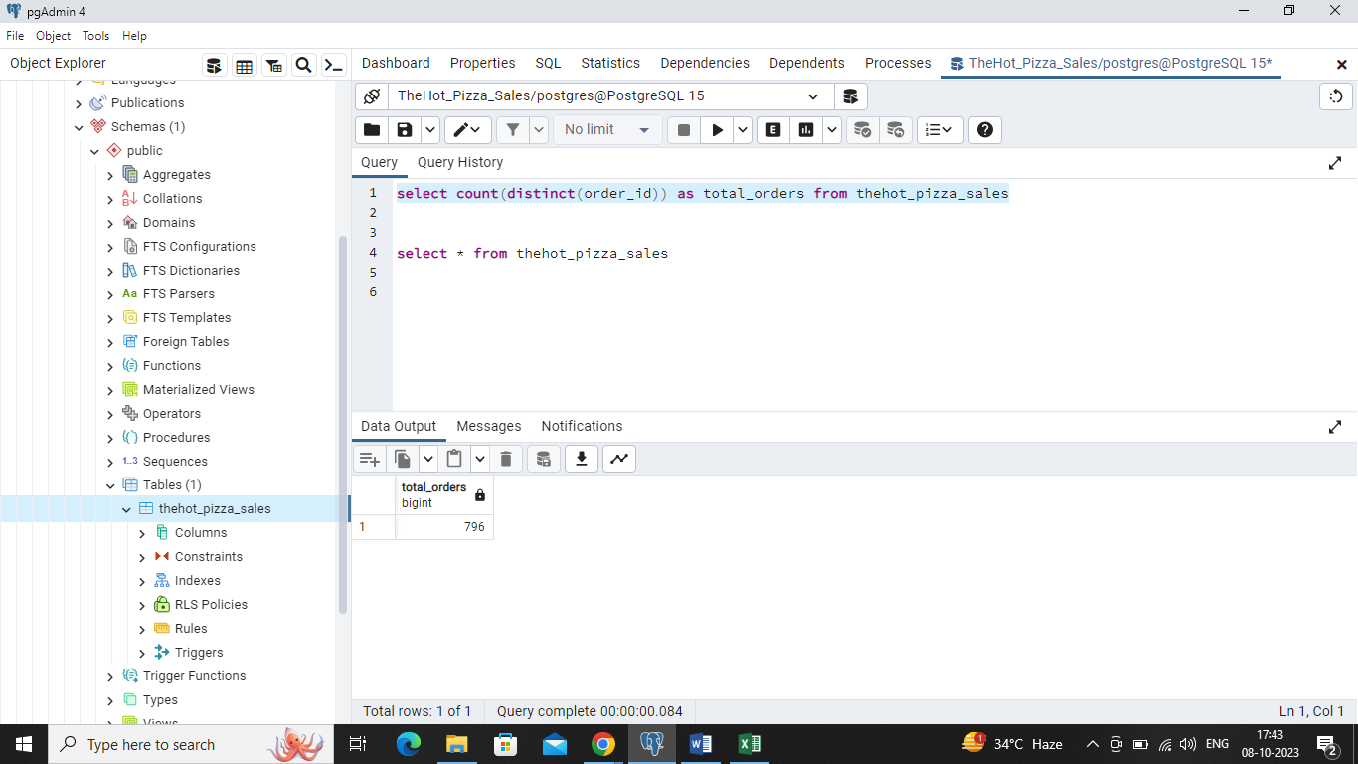

**5- Average pizzas per order :** ***The average number of pizzas sold per order, calculated by dividing the total number of pizzas sold by the total number of orders.***

select cast(cast (sum(quantity) as decimal(10,2)) / cast(count(distinct order_id) as decimal(10,2)) as decimal(10,2)) as avg_pizzas_per_order from thehot_pizza_sales

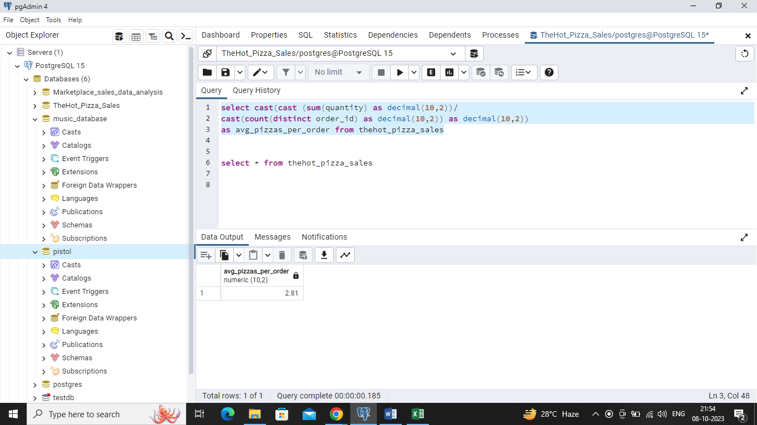

**6- Daily trend for total orders :**

select to_char(order_date, 'day') as order_day, count(distinct order_id) as total_orders from thehot_pizza_sales

group by order_day

order by order_day desc

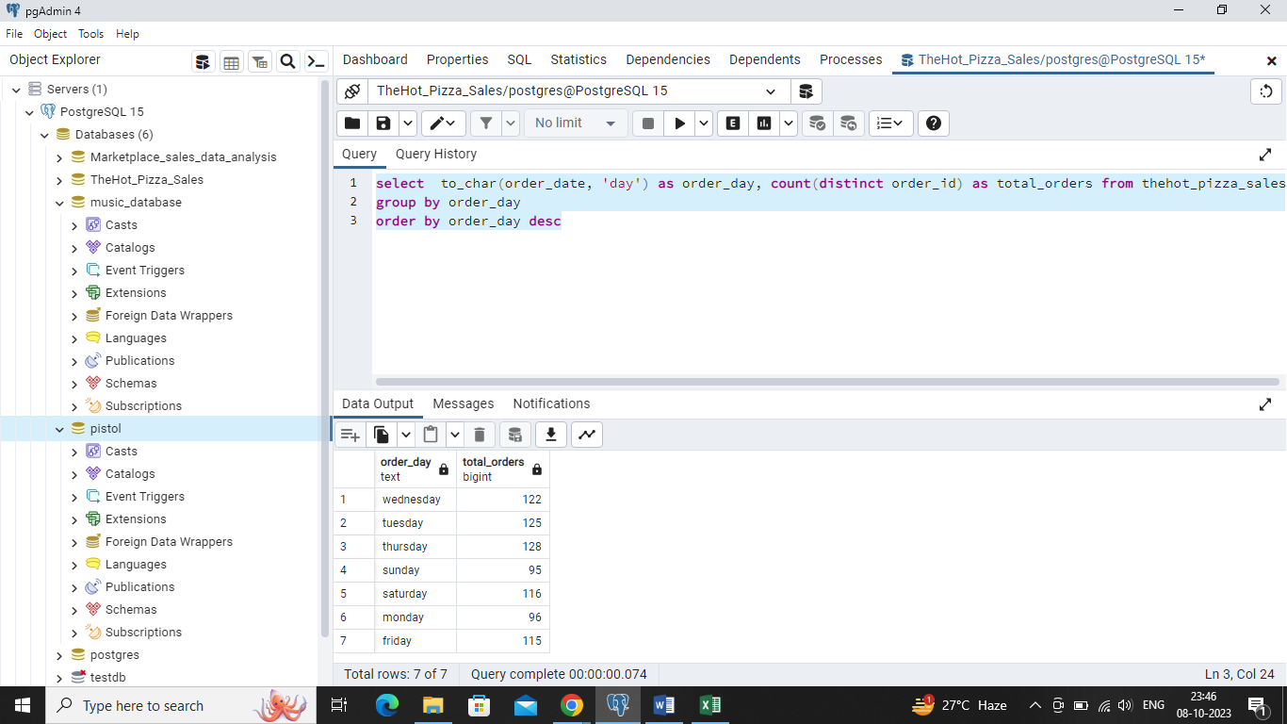

**7- Monthly trend for total order :**

select to_char(order_date, 'month') as order_day, count(distinct order_id) as total_orders from thehot_pizza_sales

group by order_day

order by order_day desc

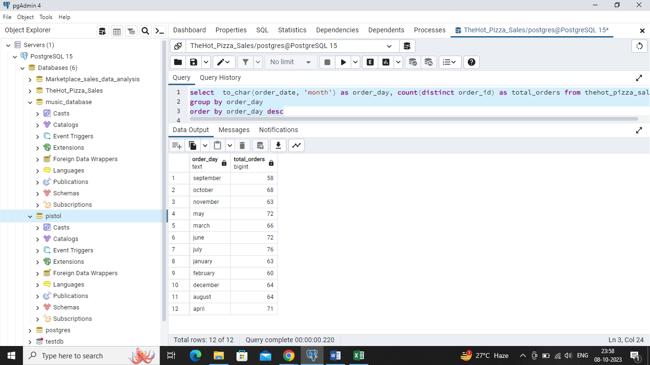

**8- Percentage of sales by pizza category :**

select pizza_category, sum(total_price) *100/(select sum(total_price) from thehot_pizza_sales) as total_sales from thehot_pizza_sales

group by pizza_category

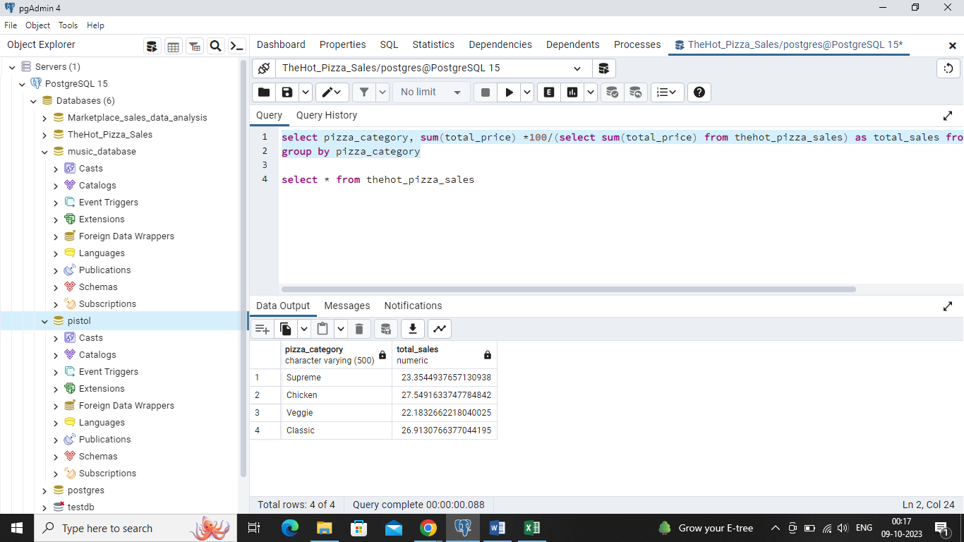

**9- Percentage of sales by pizza size :**

select pizza_size, sum(total_price) as total_sales, sum(total_price)*100/(select sum(total_price) from thehot_pizza_sales) as total_sales_percentage from thehot_pizza_sales

group by pizza_size

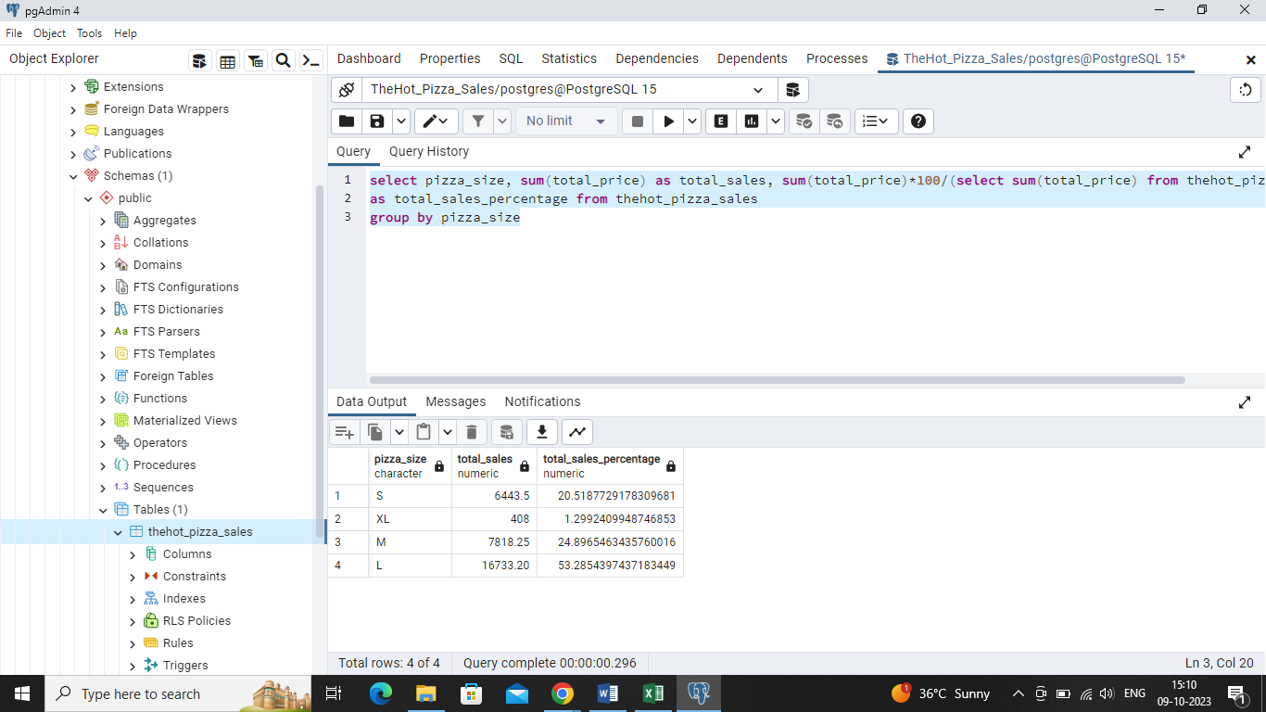

**10- Bottom 5 sellers by (a) revenue, (b) total quantity and (c) total orders**

**(a)** select pizza_name, sum(total_price) as total_revenue from thehot_pizza_sales

group by pizza_name

order by total_revenue

limit 5

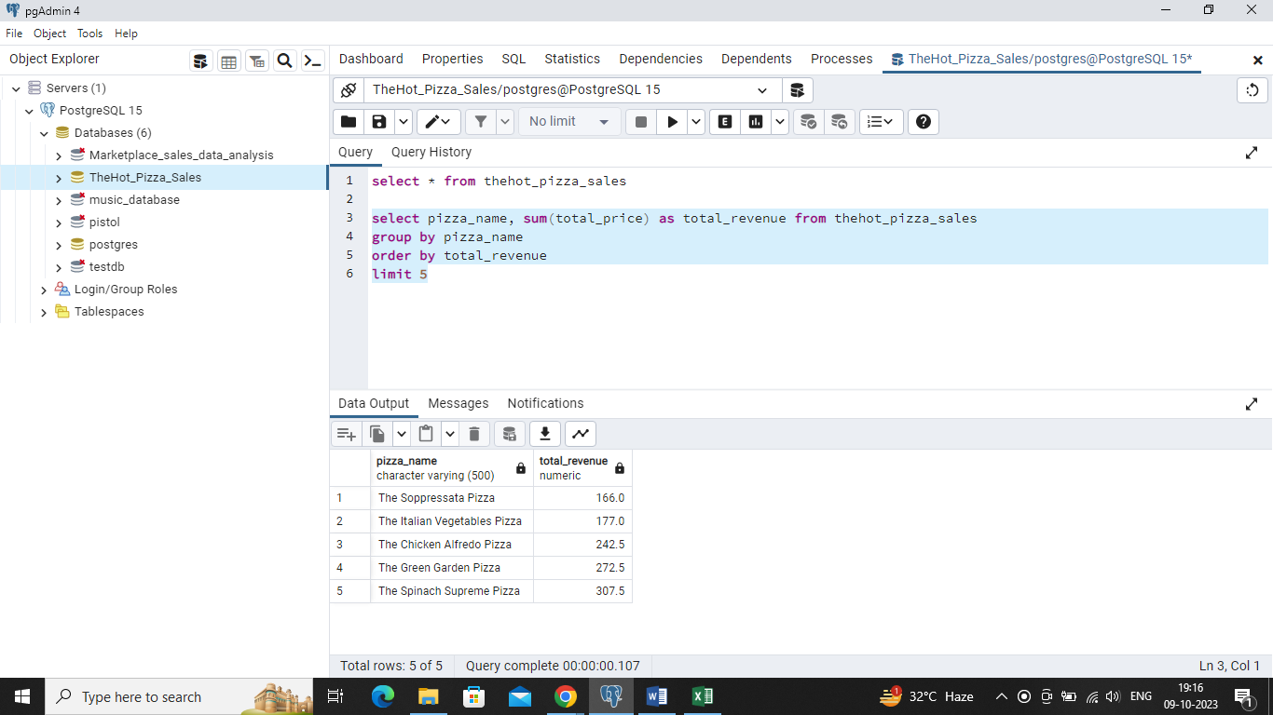

**(b)** select pizza_name, sum(quantity) as total_quantity from thehot_pizza_sales

group by pizza_name

order by total_quantity

limit 5

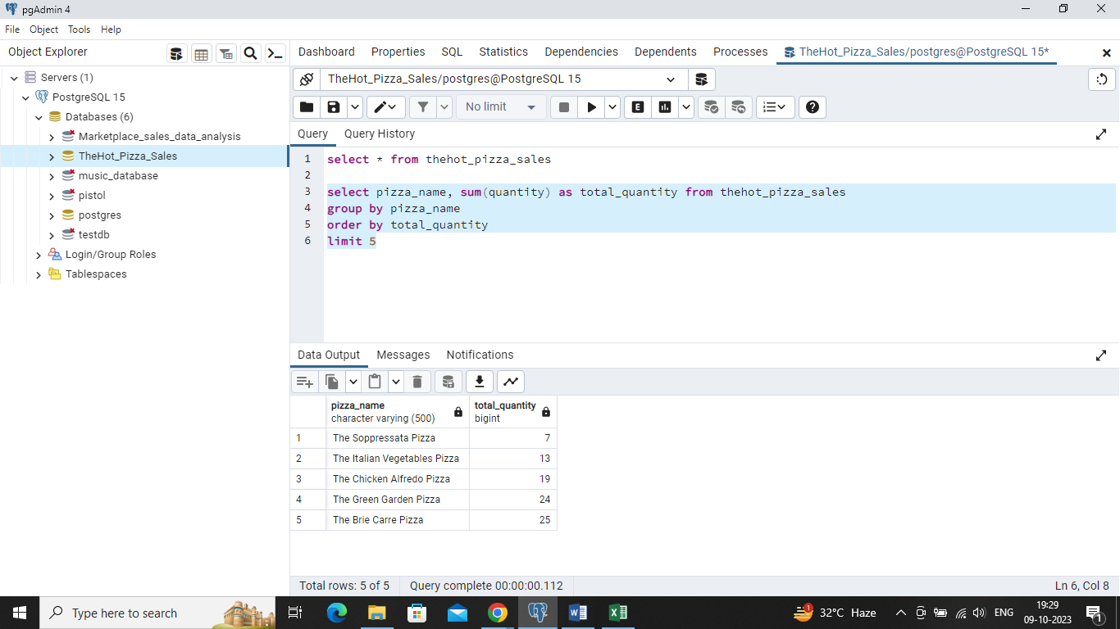

**(c)** select pizza_name, count(order_id) as total_orders from thehot_pizza_sales

group by pizza_name

order by total_orders

limit 5

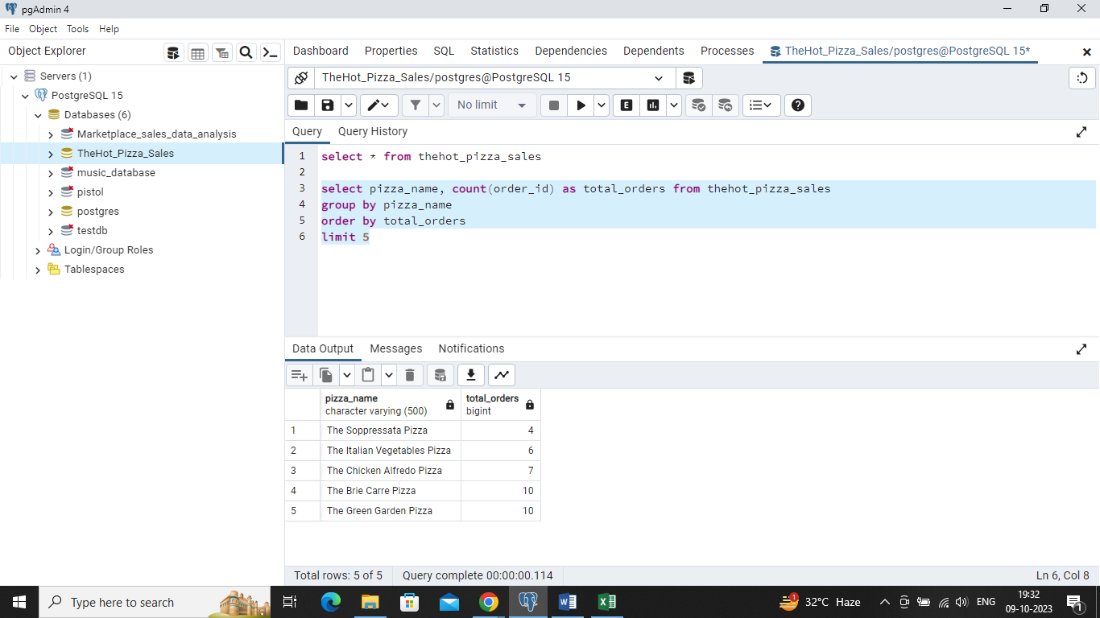

**11- Top 5 sellers by (a) revenue, (b) total quantity and (c) total orders**

(a) select pizza_name, sum(total_price) as total_revenue from thehot_pizza_sales

group by pizza_name

order by total_revenue Desc

limit 5

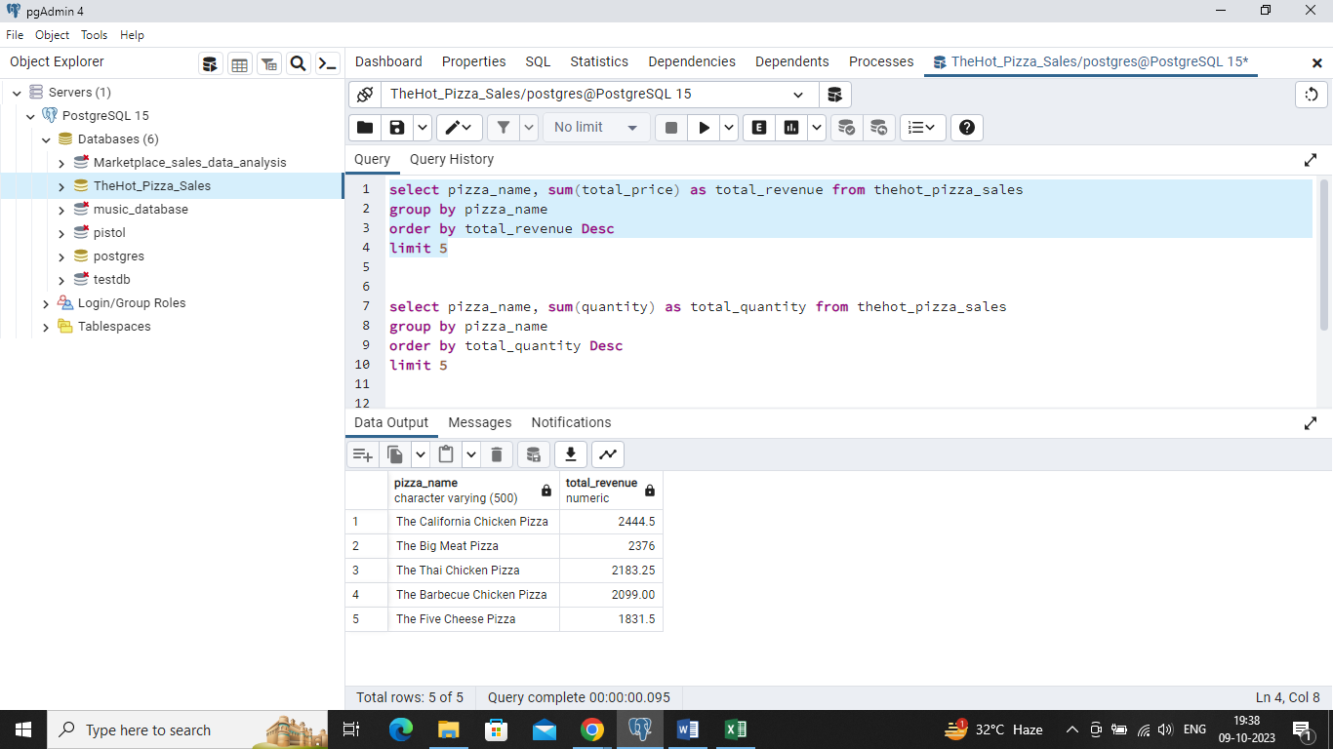

**(b)** select pizza_name, sum(quantity) as total_quantity from thehot_pizza_sales

group by pizza_name

order by total_quantity Desc

limit 5

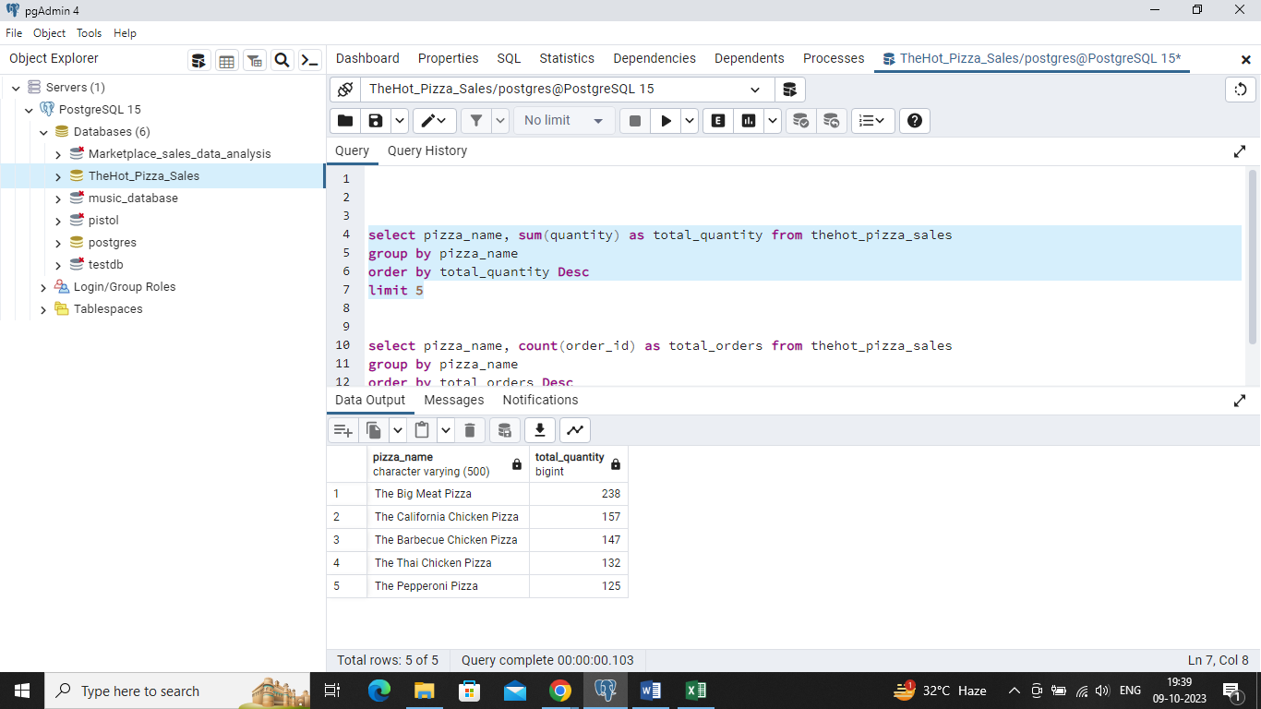

**(c)** select pizza_name, count(order_id) as total_orders from thehot_pizza_sales

group by pizza_name

order by total_orders Desc

limit 5

